Bratislava Trail Run 50 KM – Race Information
📅 Date: October 3, 2026
📍 Location: Malokarpatské Námestie 1, 84103 Bratislava – Lamač, Slovakia
Mapa
GPS: 48° 11′ 41.3″ N, 17° 3′ 7.5″ E
Registration: https://karpatyrun.sk

Program
08:00 – Registration (bring printed and signed ticket)
08:40 – Race briefing
08:45 – Group walk to the start line (700 m from venue)
15:00 – Award ceremony (men & women)

Start / Finish
Start: 700 m from Malokarpatské Námestie (group walk 15 min before start)
Finish: Malokarpatské Námestie 1, Bratislava – Lamač

Routes
30 km: From Lamač to Biely Kríž and back. A diverse and scenic trail with forest climbs, descents, and panoramic views of the Little Carpathians.
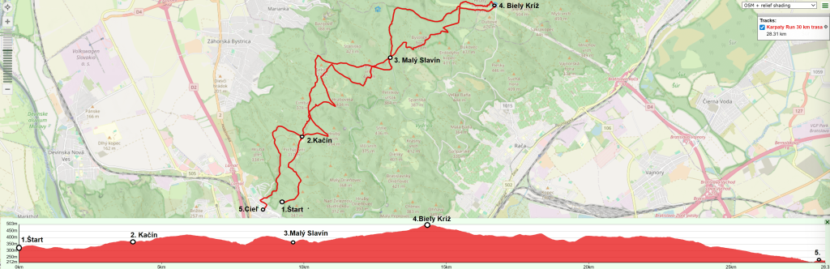
20 km: A shorter version of the 30 km route, looping around Malý Slavín – ideal for runners seeking endurance and enjoyment.
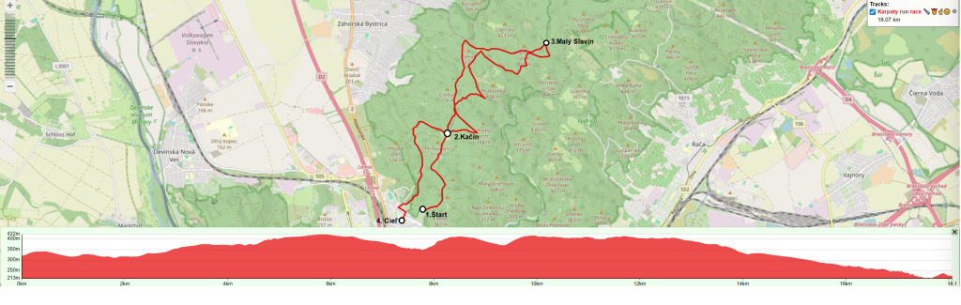
Surface composition:
• 73% forest roads (wide gravel tracks)
• 27% mountain trails (narrow single tracks)

Refreshment Stations
30 km course:
- 3 km – Kačín
- 8 km – Malý Slavín
- 15 km – Biely Kríž (self-service + purchase possible)
- 20 km – Malý Slavín
- 27 km – Kačín
- 30 km – Finish
20 km course:
- 3 km – Kačín
- 8 km – Malý Slavín
- 15 km – Kačín

Mandatory Equipment
• Race bib on the front side of the body
• Fully charged mobile phone
• Poles allowed
• Headphones allowed

Recommended Equipment
• Rain or windproof jacket
• Thermal foil
• Spare T-shirt or socks
• Blister plasters, magnesium, supplements
• GPX route uploaded to watch

Medical & Safety
First aid available at:
• Malokarpatské Námestie
• Malý Slavín

Facilities
• Storage area, toilets, and restaurants at Malokarpatské Námestie
• Playground
• Nearby parking
• Bicycle lock area available

Contact
Organizer: +421 905 599 435
(The phone number is also displayed on route marking ribbons.)

